

**Princess Sumaya University for Technology**

**King Abdullah II Faculty of Engineering**

**Microprocessors & Embedded Systems Course  
 Documentation Report - Laser Engraver   
Salma Salah 20190358  
Ahmad Al-Zoul 20190492   
Sereen Abdallah 20190212**

Table of Contents

|  |  |
| --- | --- |
| Abstract | 2 |
| Introduction | 2 |
| Background | 2 |
| Mechanical Design | 3 |
| Electrical Design | 4 |
| Problems and Solutions | 7 |
| Circuit Diagram | 8 |
| Software Design | 9 |
| Final Results | 10 |
| Conclusion | 11 |
| References | 12 |

Abstract

This report documents the design and implementation of a laser engraver using a PIC16f877A microcontroller and a stepper motor with stepper drivers. The PIC16f877a is programmed to control the stepper motor, which in turn controls the movement of the laser engraver's head. The stepper drivers are used to regulate the power supply to the stepper motor, ensuring accurate and precise movement of the laser engraver. The report includes information on the circuit design, programming, and testing of the laser engraver, as well as any challenges that were encountered and overcome during the development process. Overall, the laser engraver demonstrates the capabilities of the PIC16f877a microcontroller and stepper motor in creating a precise and efficient laser engraving machine.

Introduction

A laser engraver is a machine that uses a laser beam to etch designs and patterns onto various materials, such as wood, metal, and plastic. This documentation report will provide an overview of the hardware and software components used to build a laser engraver using the PIC16F877A microcontroller, stepper motors, and an Arduino UNO. The PIC16F877A will be used to control the stepper motors, while the Arduino UNO will be used to read G-code files from an SD card, which contains the information about the image to be engraved on the material. This report will explain how the G-code is used to control the movement of the stepper motors and the laser, resulting in high-quality engravings.

Background

The PIC16F877A is a microcontroller manufactured by Microchip Technology. It features a wide range of peripherals and a powerful instruction set, making it well-suited for a variety of applications, including laser engraving. The PIC16F877A will be used to control the stepper motors, which are responsible for moving the laser and the material in the x and y-axis.

Stepper motors are a type of electric motor that can rotate in small, precise increments, making them ideal for applications that require precise positioning and control. They are commonly used in robotics, CNC machines, and 3D printers.

Stepper drivers are electronic devices that provide the necessary current and voltage to drive stepper motors. They also provide control signals to the stepper motor, allowing for precise control of the motor's position and speed.

The Arduino UNO is a microcontroller board based on the ATmega328P. It will be used as a bridge between the PIC16F877A and the SD card reader. The SD card reader will read the G-code file which contains the information about the image to be engraved on the material. The G-code will be sent to the PIC16F877A via serial communication, which will then be used to control the movement of the stepper motors and the laser.

Mechanical Design

The mechanical part of the laser engraver includes a frame, a gantry, and a table. The frame is made of wood and provides support and stability for the other components. The gantry, also made of wood, holds the laser and moves in the x and y-axis. The table is fixed and made of wood; it holds the material being engraved. The gantry is connected to stepper motors through Flexible couplers, which transfer the rotational motion of the motors to the linear motion of the gantry. The stepper motors and drivers control the movement of the gantry to engrave the desired image. The design is compact and lightweight, which makes it more portable.

**Tools used to make the structure**

* L500MM 8MM LEAD SCREW AND NUT
* MICRO NORMALLY OPEN CLOSE LIMIT SWITCH
* LM8LUU 8MM LONG LINEAR BALL BEARING BUSHING
* MR105 MINIATURE BEARINGS BALL MINI BEARING (5MM*10MM*4MM)
* FLEXIBLE COUPLER 5MM X 8MM

Electrical Design

**Technical Specifications**

**PIC16f877A**

* Operating voltage: 4-5.5V
* CPU speed: 20MHz
* Memory: 8K bytes of Flash Program Memory, 368 bytes of Data Memory (RAM)
* I/O pins: 33
* Peripherals: 10-bit Analog-to-Digital (A/D) converter, timers, USART, MSSP (SPI/I2C)
* Instruction set: 35 instructions

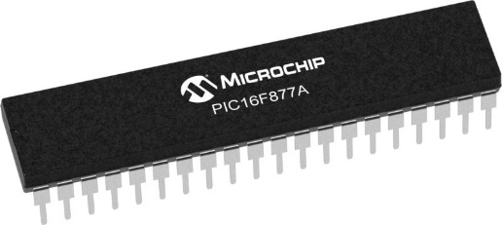

### NEMA 17 Stepper Motor

* Rated Voltage: 12V DC
* Current: 1.2A at 4V
* Step Angle: 1.8 deg.
* No. of Phases: 4
* Motor Length: 1.54 inches
* 4-wire, 8-inch lead
* 200 steps per revolution, 1.8 degrees
* Operating Temperature: -10 to 40 °C
* Unipolar Holding Torque: 22.2 oz-in

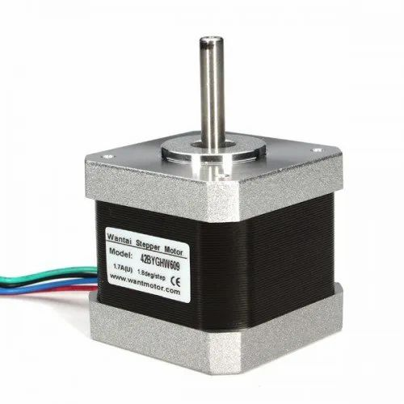

**Arduino UNO**

* Microcontroller: ATmega328P
* Operating Voltage: 5V
* DC Current per I/O Pin: 40 mA
* DC Current for 3.3V Pin: 50 mA
* Serial communication: 1x UART (RX/TX), 1x USB-UART bridge
* Support for serial communication protocols such as RS-232, RS-485, and TTL-level UART

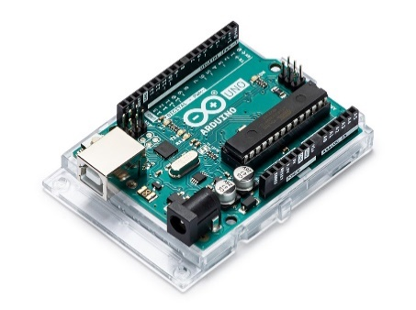

**A4988 Stepper Motor Driver**

* Maximum operating voltage: 35 V
* Continuous current per phase: 1 A
* Maximum current per phase: 2 A
* Maximum logic voltage: 5.5 V
* Microstep resolutions: 1, 1/2, 1/4, 1/8, 1/16
* Size: 0.6″ × 0.8″
* Weight: 1.3 g

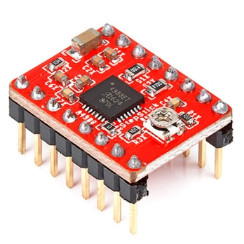

**Laser**

* Laser Power: 5.5W/ 10W/ 20W/ 30W/ 40W (Optional)
* Adjustable Focal Length: 5.5W/ 10W/ 20W (20-70mm)
* Fixed Focal Length: 30W (126mm)/ 40W (150mm)
* Material: Aluminum Alloy + Electronic Components
* Wave Length: 450nm
* Luminous Color: Blue
* Operating Voltage: 12V
* PWM/ TTL Input: DC 3.3V-12V, 100Hz-50KHz
* Input Interface: XH2.54-3 Pin (+, -, PWM/ TTL)

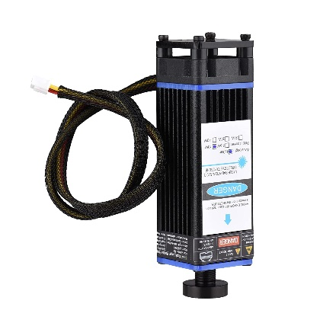

**Micro SD card**

* Card Compatibility: Micro SD card (also known as TransFlash or TF card)
* Card Capacity: Up to 2TB
* Data Transfer Rate: Up to 480Mbps (depending on the card)
* Operating Voltage: 2.7V - 3.6V
* Operating Temperature: -25°C to 85°C
* Dimension: 15x11x1 mm (approx)
* Interface: USB 2.0, USB 3.0 or USB-C
* Support for SDHC and SDXC
* Plug and play, no additional driver is required  
  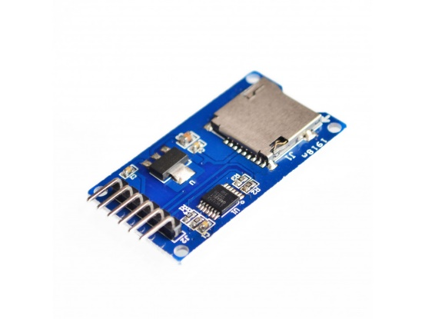

**Components works together to engrave the desired image on the material**

* PIC16F877A Microcontroller: The PIC16F877A is the brain of the machine. It is responsible for controlling the stepper motors and stepper drivers based on the G-code commands received from the Arduino UNO through serial communication.
* NEMA 17 Stepper Motors: The NEMA 17 stepper motors are responsible for moving the laser and the material in the x and y-axis, which is required to engrave the desired image. They have a step angle of 1.8 degrees per step, which allows for precise control of the laser's movement over the material.
* A4988 Stepper Drivers: The A4988 stepper drivers are responsible for providing the necessary current and voltage to drive the stepper motors and sending control signals to the motors. They are used to control the movement of the NEMA 17 stepper motors in the x and y-axis, and it is used to move the laser and the material to achieve the desired image.
* Arduino UNO: The Arduino UNO is responsible for reading the G-code files from the SD card and sending the necessary commands to the PIC16F877A microcontroller via serial communication.
* SD Card: The SD card stores the G-code files that contain the instructions for the laser engraver machine.

**Briefly**, the laser engraver machine uses a combination of a PIC16F877A microcontroller, NEMA 17 stepper motors, A4988 stepper drivers, an Arduino UNO, and an SD card to engrave a desired image on a material. The G-code files containing the instructions for the machine are stored on the SD card, which is read by the Arduino UNO. The Arduino UNO then sends the necessary commands to the PIC16F877A microcontroller via serial communication. The PIC16F877A microcontroller controls the stepper motors and stepper drivers based on the commands received from the Arduino UNO. The NEMA 17 stepper motors are used to move the laser in the x and y-axis, while the A4988 stepper drivers provide the necessary current and voltage to drive the stepper motors and send control signals to the motors. This combination of components allows for precise control of the laser's movement over the material, resulting in accurate and high-quality engravings.

## 

Problems and Solutions

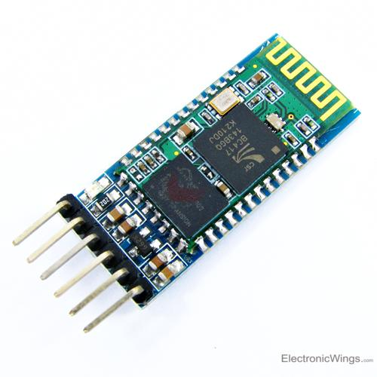Unfortunately, the pic was unable to process the G-Code commands, so we had to come up with a different way to keep the idea of serial communication alive; we ended up using a Bluetooth module (instead of Arduino and SD card) to connect serially to the PIC16f877a via the RX and TX pins, which proved to be quite useful in our project. To command the laser engraver to create three squares, we type the letter "S" into the terminal's Bluetooth Arduino Application and transfer the data to the PIC16f877A via the HC-05 Bluetooth module.

To sum up after the solution, a laser engraver project using a PIC16F877A microcontroller, stepper drivers, stepper motors, and an HC-05 Bluetooth module is a complex and sophisticated device that can be used to engrave or cut a wide variety of materials. The PIC16F877A microcontroller is responsible for controlling the stepper drivers and stepper motors, which move the laser beam in precise increments to create the desired engraving or cutting pattern. The HC-05 Bluetooth module allows the device to be controlled wirelessly via a smartphone or computer. The stepper motors and drivers ensure precise movement of the laser beam resulting in accurate engraving or cutting. This project provides an excellent opportunity to learn about microcontrollers, stepper motors, and Bluetooth communication.

Proteus Circuit Diagram

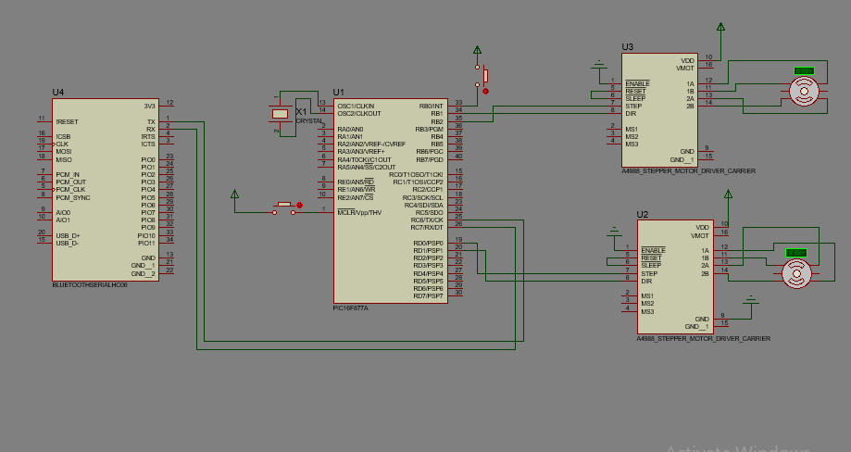

Final Result

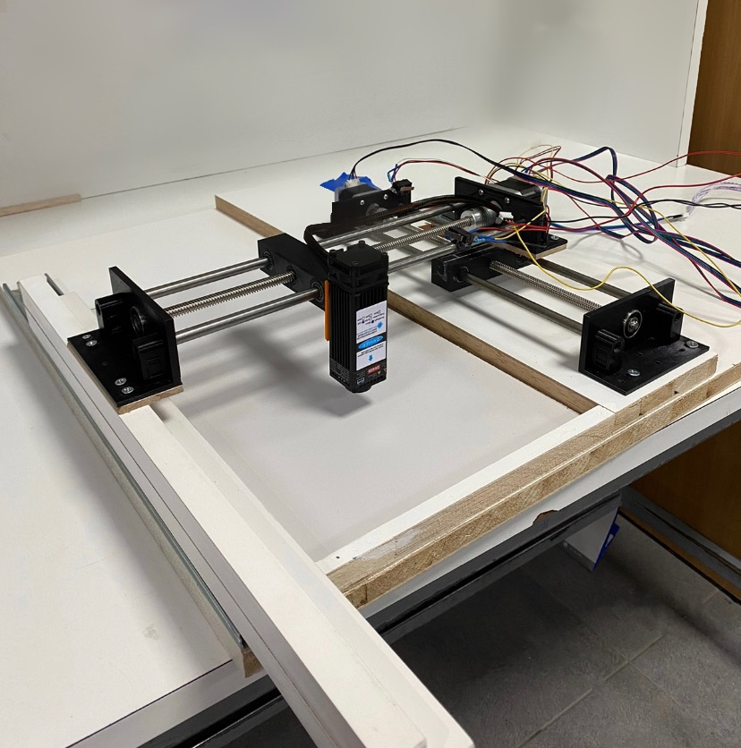

Software Design

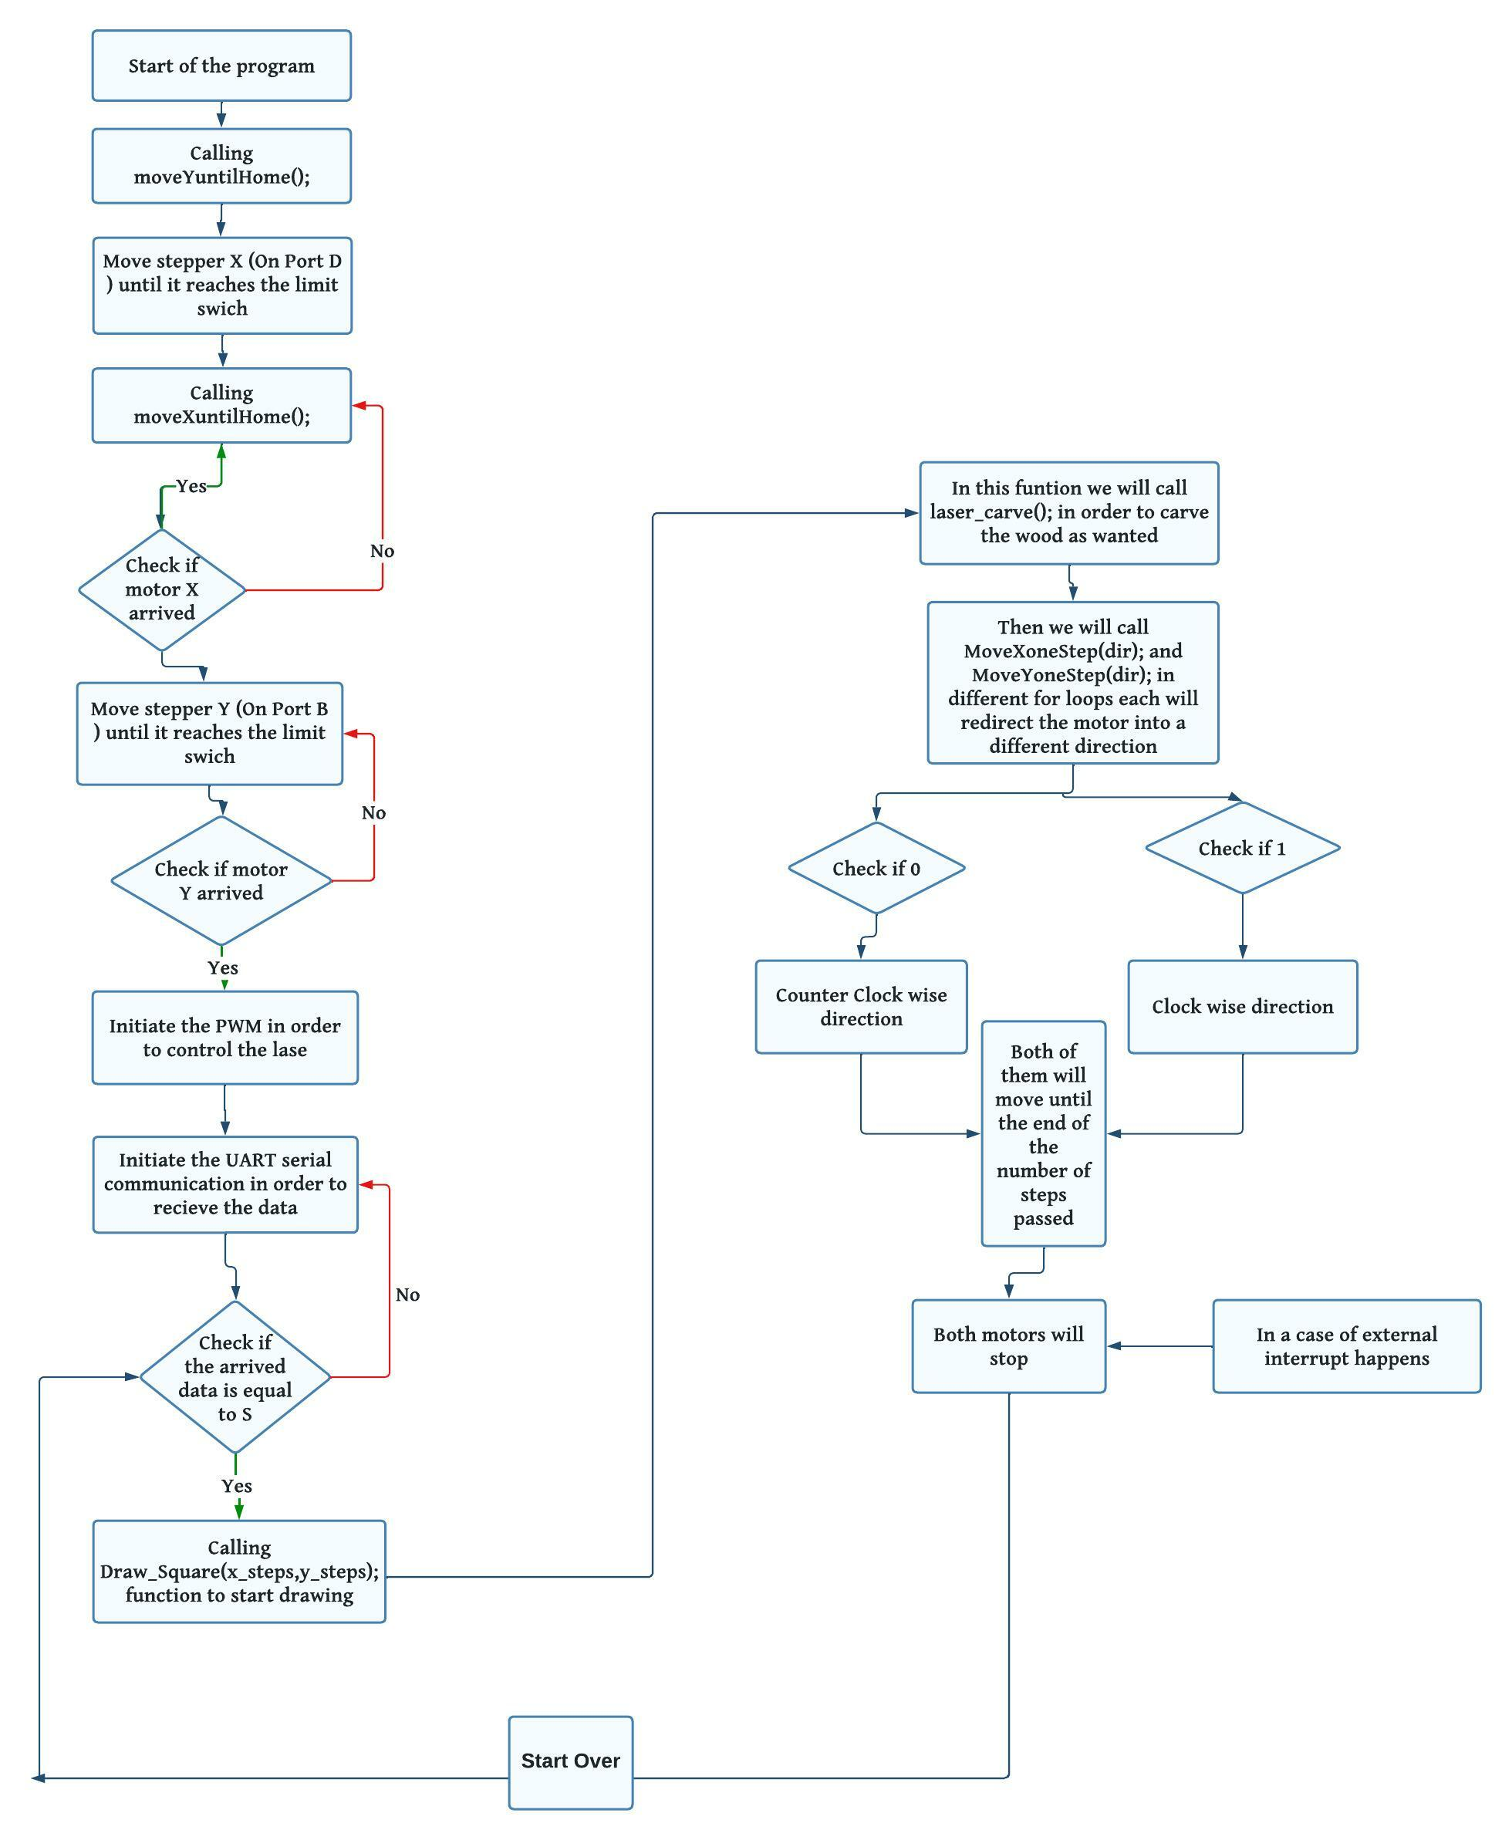

Conclusion

In conclusion, this documentation report has provided an overview of the hardware and software components used to build a laser engraver using the PIC16F877A microcontroller, resulting a high-quality engraving. This documentation report has provided a detailed explanation of how components work together to create a functional laser engraver.

References

Allegro Microsystem. DMOS Micro stepping Driver with Translator and Overcurrent

Protection. Available at <https://www.allegromicro.com/en/products/motor-drivers/brush-dc-motor-drivers/a4988>.

BPC Linear. Stepper Motor NEMA 17. Available at pbclinear.com.

PIC16F877A Datasheet (PDF) - Microchip Technology. Available at http://www.microchip.com.